Name:__________________________
The Science of
SAND

Beaches are made up of bits of materials washed onto the shore by waves. Most beaches are made of sand, but sand can be made up of many different things. From beach to beach what the sand looks like depends on many things, including where it came from, what it is made of and how it made its way onto the beach. Every grain of sand has its own story and history. Each grain is a tiny world in itself!

My sand comes from _______________________________

1. What color is your sand? Look closely with your magnifier. The colors of your sand grains can tell you what rocks or particles your sand is made of. Check off the colors you see in your sand
____ Clear or frosty white rocks (quartz).
____ Peach, beige or reddish brown (usually feldspar).
____ Shiny black (magnetite or basalt).
____ Gold, silver or brown (usually mica).
____ Green (olivine).
____ Pink to dark red (garnet).
____ White, pink or milky color (pieces of shells or corals).

2. What other colors did you find in your sample? List them.
_____________________________________________________
3. Where do you think your sand ORIGINALLY came from? The color of a sand grain can tell us about where it came from. Based on the colors in sand, check off where your sand sample might have come from.
____ Clear, frosty white, brown, gray, silver, red, beige, peach and black grains mixed together come mostly from mountains.
____ All black or green sand is usually from the lava of volcanoes.
____ White, milky or cream colored grains are usually bits of seashells.
____ White or pink sand is usually from coral reefs in the ocean.

4. Sand Shape.
Draw a picture of one or
two of your sand grains.

5. How old is your sand? When sand first breaks off from rocks, shells or coral it is usually very pointy and rough. As time goes on, the sand grain tumbles around in the ocean getting smooth and round. Smooth round grains are the oldest! Circle the grain shapes pictured below that best matches the grains in your sample. (River sand is often young sand, ocean sand is often old.)
Smooth and
round
Very pointy
and rough

Young Old

Is your sand young, old or middle-aged? ____________________
Why? ________________________________________________
6. How big are your sand grains? Compare your sand sample to the size chart below. Imagine the dots are grains of sand. What sizes do you find in your sample? Circle them.
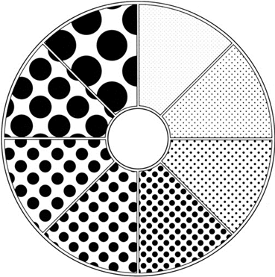
Size 1
0.1mm
Size 2
0.25mm
Size 3
0.5mm
Size 4
1.0mm
Size 5
2.0mm
Size 6
3.0mm
Size 7
5.0mm
Size 8
7.0mm

Particles from 0.06 millimeters (mm) to 2mm are considered to be sand. Particles larger than 2.0mm are considered gravel.

7. Surf’s Up! Waves wear sand down too. Based on grain size, check off if you think your sand came from a beach with big, small, or no waves at all.
____ Big grains of sand are probably from a beach with big, powerful waves that churn up rocks, shells and coral. Big waves also wash away the small grains.
____ Small grains are probably from a beach with small, gentle waves. Small, fine grains of sand may also be from sand dunes. Wind carries the grains there, but they are generally small and light.
____ Tiny grains are probably from beaches with little to no wave action.
8. Do you have mostly sand or gravel?
Draw a picture of your sand
grain sizes in the box.

9. How well sorted are your sand grains? Sorting is a result of how the sand particles were deposited. Poorly sorted sand shows a wide range of grain sizes, while well-sorted sand has similar sized grains. Which describes the sorting of your sand? Circle one.
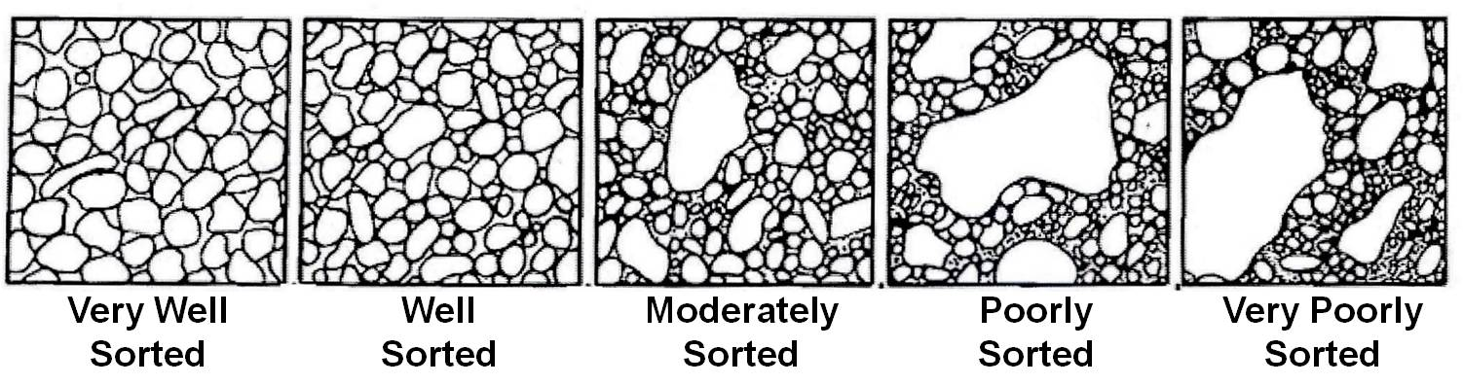
Very well
sorted
Well
sorted
Moderately
sorted
Poorly
sorted
Very poorly
sorted

10. Feel the breeze! Wind can break up sand particles and make them more round, smooth and all about the same size. Is your sand from a windy beach or a beach with little wind?
____ Yes, my sand grains are mostly the same size, my sample came from a windy beach!
____ No, my sand grains are all different sizes, my sample came from a beach with little wind.

